Discrete Mathematics

Textbook: Introductory Discrete Mathematics by Robert F. Blitzer
1.
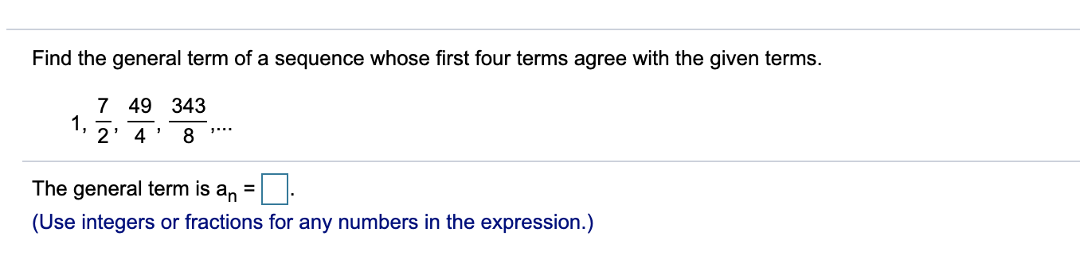
2.
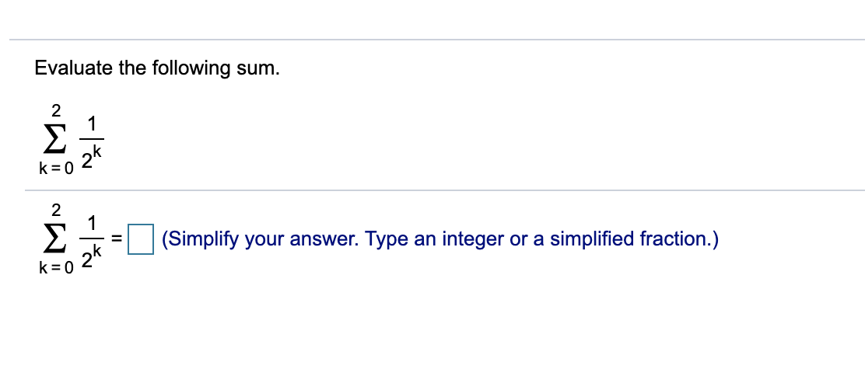
3.
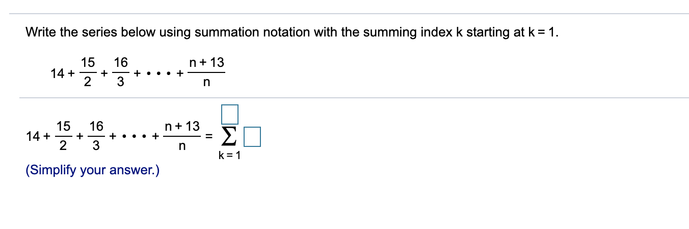
4.
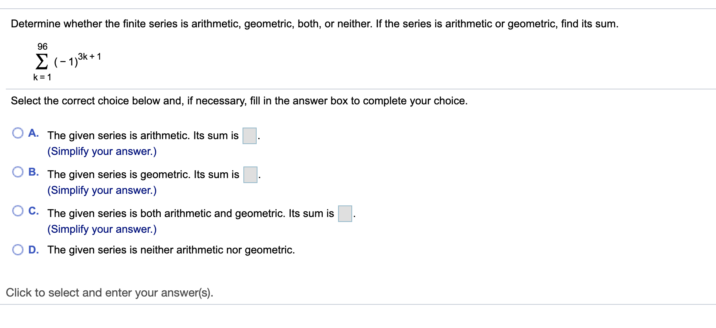
5.
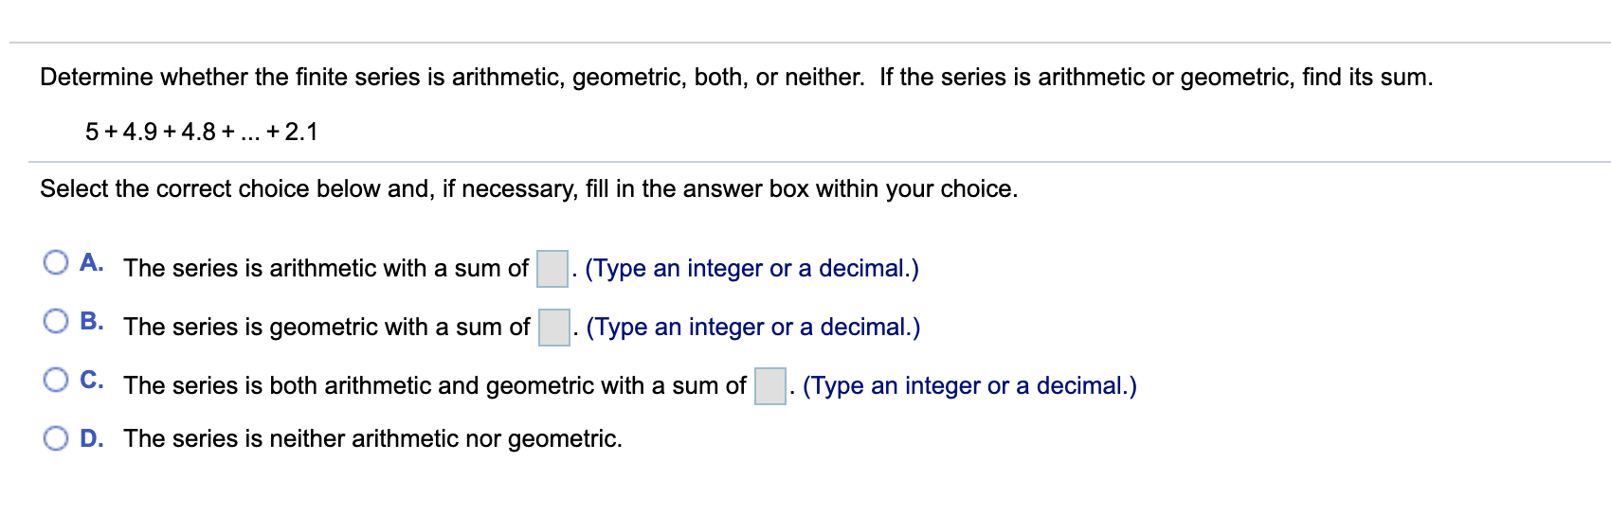
6.
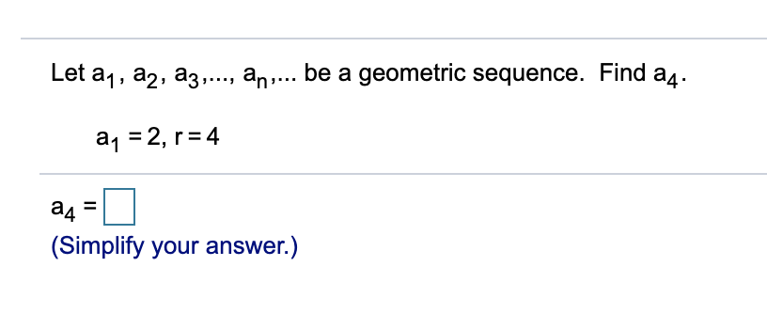

7.
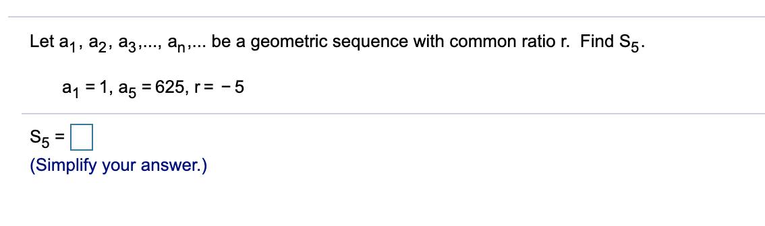
8.
